## ABSTRACT

*Automatic emotion recognition based on facial expression is an interesting research field, which has been presented and applied in several areas such as safety, health and in human machine interfaces. Researchers in this field are interested in developing techniques to interpret, code facial expressions, and extract these features in order to have a better prediction by computer. With the remarkable success of deep learning, the different types of architectures of this technique are exploited to achieve a better performance. This paper presents the design of an artificial intelligence (AI) system capable of emotion detection through facial expressions. It discusses about the procedure of emotion detection, which includes basically three main steps: face detection, features extraction, and emotion classification. This paper proposed a convolutional neural network (CNN) based deep learning architecture for emotion detection from images. We underline on these contributions treated, the architecture and the databases used and we present the progress made by comparing the proposed methods and the results obtained. The interest of this paper is to serve and guide researchers by review recent works and providing insights to make improvements to this field.*

## TABLE OF CONTENTS Page

DECLARATION ................................................................................................... ii

CERTIFICATE ..................................................................................................... iii

ACKNOWLEDGEMENTS .................................................................................. iv

**ABSTRACT** ......................................................................................................... v

LIST OF FIGURES................................................................................................ vii

LIST OF ABBREVIATIONS ............................................................................... viii

**CHAPTER 1:** INTRODUCTION..........................................................................9

1.1. MOTIVATION................................................................................................ 9

1.2. PROBLEM STATEMENT.............................................................................. 9

1.3. OBJECTIVES ………………………………………………………………...9

1.4. SCOPE AND APPLICATIONS......................................................................10

**CHAPTER 2:** LITERATURE SURVEY ............................................................. 11

**CHAPTER 3:** METHODOLOGY AND TECHNOLOGY................................. 14

3.1. RESEARCH METHADOLOGY................................................................... 14

3.2. DATA COLLECTION................................................................................... 14

3.3 SOFTWARE REQUIREMENT SPECIFICATIONS……………………….15

3.4 FEASIBILITY STUDY………………………………………………………15

3.5 SOFTWARE AND HARDWARE REQUIREMENTS……………………...16

3.6 SYSTEM DESIGNS…………………………………………………………17

**CHAPTER 4:** RESULT ANALYSIS AND DISCUSSION ............................... 20

4.1. RESULT ANALYSIS................................................................................... 20

**CHAPTER 5:** CONCLUSIONS AND FUTURE WORK ................................. 22

5.1. CONCLUSIONS............................................................................................ 22

5.2. FUTURE SCOPE........................................................................................... 22

5.3 IMPACT ANALYSIS………………………………………………………. 23

**REFERENCES**... ................................................................................................ 24

**APPENDIX A:** RESEARCH PAPER................................................................ 25

**APPENDIX B:** SOURCE CODE ....................................................................... 27

**LIST OF FIGURES**

1. FIGURE 1: Example images in FER 2013 dataset.
2. FIGURE 2: System Diagram
3. FIGURE 3: System Flowchart: Flowchart of Training
4. FIGURE 4: System Flowchart: Flowchart of Testing
5. FIGURE 5: Sequence Diagram
6. FIGURE 6: Use Case Diagram
7. FIGURE 7: Convolution Neural Networks (CNNs) Model Stage
8. FIGURE 8: Graphs for Accuracy and Loss (Training Vs Validation)
9. FIGURE 9: Confusion Matrix

**LIST OF ABBREVIATIONS**

1. AI: Artificial Intelligence
2. CNN: Convolution Neural Networks
3. AU: Artificial Units
4. FER: Facial Expression Recognition
5. RNN: Recurrent Neural Network
6. DBN: Deep Belief Networks
7. ACNN: Attention based Convolution Neural Networks
8. PCA: Principal Component Analysis
9. SGD: Stochastic Gradient Descent

## CHAPTER -1

**Introduction**

Facial expressions play a crucial role in human communication, conveying rich emotional information. Facial emotion recognition aims to automatically detect and interpret emotions expressed through facial expressions, enabling machines to perceive and understand human emotions. This ability has vast applications, including affective computing, personalized user experiences, mental health diagnosis, and social robotics.The paper begins by discussing the significance of facial emotion recognition in various domains and its potential impact on human-computer interaction. It also discusses the impact of facial emotion detection and recognition on today’s society. It provides an overview of the underlying techniques and methodologies employed in facial emotion recognition, such as feature extraction, machine learning algorithms, and deep learning approaches.Next, recent advancements in the field are explored, including the utilization of convolutional neural networks (CNNs), recurrent neural networks (RNNs), and multimodal approaches combining facial features with other modalities like audio and physiological signals. The paper also highlights benchmark datasets and evaluation metrics commonly used for performance assessment.Finally, the paper presents potential future directions for research, including real-time and dynamic emotion recognition, multimodal fusion techniques, robustness to environmental factors, and the development of large-scale, diverse datasets. It emphasizes the need for interdisciplinary collaborations among computer scientists, psychologists, and sociologists to advance the field.

* 1. **MOTIVATION**

In today’s networked world the need to maintain security of information or physical property is becoming both increasingly important and increasingly difficult. In countries like Nepal the rate of crimes are increasing day by day. No automatic systems are there that can track person’s activity. If we will be able to track Facial expressions of persons automatically then we can find the criminal easily since facial expressions changes doing different activities. So we decided to make a Facial Expression Recognition System. We are interested in this project after we went through few papers in this area. The papers were published as per their system creation and way of creating the system for accurate and reliable facial expression recognition system. As a result we are highly motivated to develop a system that recognizes facial expression and track one person’s activity.

**1.2. PROBLEM STATEMENT**

Facial emotion recognition and detection is a challenging problem that has significant applications in various fields such as psychology, human-computer interaction, and social robotics. However, there are still many limitations in accurately recognizing and detecting facial emotions, especially in real-world environments. The research problem is to develop an efficient and robust facial emotion recognition and detection system that can accurately identify emotions from facial expressions in real-time and under different lighting and environmental conditions, to improve the usability and effectiveness of emotion recognition applications.

* 1. **OBJECTIVES**

1. To develop a facial expression recognition system.

2. To experiment machine learning algorithm in computer vision fields.

3. To detect emotion thus facilitating Intelligent Human-Computer Interaction.

* 1. **SCOPE AND APPLICATIONS**

Facial emotion recognition and detection is needed because it has many potential applications in various fields, some specific examples of the need for facial emotion recognition and detection:

Healthcare: Facial emotion recognition and detection can help detect and monitor mental health conditions such as depression, anxiety, and post-traumatic stress disorder (PTSD). The ability to detect and monitor these conditions through facial expressions can improve diagnosis and treatment outcomes, leading to better patient care.

Education: Facial emotion recognition and detection can help personalize the learning experience for students. By recognizing facial expressions, a system can identify when a student is struggling, frustrated, or bored, and adjust the learning material accordingly to better engage the student and improve learning outcomes.

Security: Facial emotion recognition and detection can enhance security systems by identifying potential threats, such as individuals who are agitated, angry, or nervous. This technology can help improve public safety in places such as airports, train stations, and other public spaces.

Psychology: Facial emotion recognition and detection can be used to study human emotions and behaviour, which can provide insights into the psychology of individuals and groups. This technology can help researchers better understand how emotions are expressed, perceived, and communicated, leading to a deeper understanding of human behaviour.

Human-Computer Interaction: Facial emotion recognition and detection can improve the interaction between humans and computers by enabling machines to recognize and respond to human emotions. This technology can improve the usability and effectiveness of virtual reality, gaming, and other computer-based applications. In summary, facial emotion recognition and detection is needed because it has the potential to improve human well-being and safety, enhance learning outcomes, advance psychological research, and improve the effectiveness of human-computer interaction.

## CHAPTER -2

**Literature Survey**

Facial emotion detection using deep learning has emerged as a powerful technique for accurately recognizing and analyzing human emotions from facial expressions. This literature survey aims to provide an overview of the advancements, methodologies, and key research papers related to this field.

* **"A Multi-Task Deep Learning Approach for Facial Emotion Recognition and Action Unit Detection" by Li (2018)**

A multi-task deep learning approach was proposed for facial emotion recognition and action unit detection. The study aimed to simultaneously predict emotions and action units from facial expressions using a single network architecture. The proposed model utilized a shared feature extraction layer followed by separate branches for emotion classification and action unit detection. The study highlighted the potential benefits of jointly learning emotion recognition and action unit detection, contributing to a better understanding of facial expressions and human behavior

* **"Facial Expression Recognition using Deep Learning: A Comprehensive Review" by Singh and Tripathi (2019)**

Singh and Tripathi (2019) conducted a comprehensive review on facial expression recognition using deep learning techniques. The study presented an overview of the advancements, methodologies, and challenges in this field. Various deep learning architectures, including convolutional neural networks (CNNs) and recurrent neural networks (RNNs), were discussed, along with their applications in facial expression recognition. The review also highlighted the importance of datasets and evaluation metrics for benchmarking different models. Additionally, the study addressed challenges such as occlusion, pose variation, and limited data availability. The review provided valuable insights into the state-of-the-art techniques and future directions for facial expression recognition using deep learning.

* **"Facial Emotion Recognition with Occlusions using Deep Learning" by Vashistha (2019)**

Vashistha (2019) presented a study on facial emotion recognition with occlusions using deep learning. The research aimed to address the challenge of occlusions in facial expressions and its impact on emotion recognition accuracy. The study proposed a deep learning approach that incorporates occlusion-aware features and attention mechanisms to focus on relevant facial regions. Experimental results demonstrated the effectiveness of the proposed method in improving emotion recognition performance under occlusion conditions. The study emphasized the importance of considering occlusions in facial emotion recognition systems and provided insights into the potential of deep learning techniques to handle this challenge.

* **"Deep Facial Expression Recognition: A Review" by Ansari. (2019)**

Ansari (2019) conducted a comprehensive review on deep facial expression recognition. The study provided an overview of the advancements, methodologies, and challenges in this field. Various deep learning architectures, including convolutional neural networks (CNNs) and recurrent neural networks (RNNs), were discussed, along with their applications in facial expression recognition. The review also highlighted the importance of datasets, preprocessing techniques, and performance evaluation metrics. Additionally, the study discussed the challenges faced in deep facial expression recognition, such as variations in pose, lighting conditions, and occlusions. The review concluded by providing future research directions and potential applications of deep learning in facial expression recognition.

* **"Facial Emotion Recognition using Deep Learning: A Survey" by Bhagat. (2019)**

Bhagat (2019) conducted a survey on facial emotion recognition using deep learning. The study provided an extensive overview of the advancements, methodologies, and applications of deep learning techniques in facial emotion recognition. Various deep learning models, including convolutional neural networks (CNNs), recurrent neural networks (RNNs), and hybrid models, were discussed, along with their advantages and limitations. The survey also covered important aspects such as datasets, preprocessing techniques, feature extraction, and performance evaluation metrics. Additionally, the study discussed challenges in facial emotion recognition, such as limited data, class imbalance, and domain adaptation. The survey concluded by highlighting future research directions and potential areas of improvement in the field of facial emotion recognition using deep learning.

* **"Facial Emotion Recognition based on Convolutional Neural Network with Dropout and Batch Normalization" by Chen (2020)**

Chen (2020) proposed a facial emotion recognition approach based on a convolutional neural network (CNN) with dropout and batch normalization. The study aimed to improve the performance of emotion recognition by addressing overfitting and enhancing the training process. The proposed model incorporated dropout and batch normalization techniques to regularize the network and improve generalization. Experimental results on benchmark datasets demonstrated the effectiveness of the proposed approach in achieving competitive accuracy in facial emotion recognition. The study highlighted the importance of regularization techniques in deep learning models and their potential to enhance the robustness and generalization capabilities of facial emotion recognition systems.

* **"Facial Emotion Recognition with Inception Residual Networks and Transfer Learning" by Yu. (2020)**

Yu (2020) presented a study on facial emotion recognition using Inception Residual Networks (IRNs) and transfer learning. The research aimed to leverage the power of deep convolutional neural networks (CNNs) and transfer learning to improve the accuracy of facial emotion recognition. The study utilized pre-trained IRN models, such as InceptionV3 and ResNet, and fine-tuned them on facial emotion datasets. Experimental results demonstrated that the proposed approach achieved state-of-the-art performance in recognizing facial emotions. The study highlighted the effectiveness of transfer learning in leveraging pre-trained models for improved emotion recognition and emphasized the potential of IRNs in this field.

* **"Deep Learning for Facial Emotion Recognition: A Comprehensive Survey" by Hussain. (2020)**

Hussain (2020) conducted a comprehensive survey on deep learning techniques for facial emotion recognition. The study provided an extensive overview of the advancements, methodologies, and challenges in this field. Various deep learning models, including convolutional neural networks (CNNs), recurrent neural networks (RNNs), and their variants, were discussed in detail, along with their applications in facial emotion recognition. The survey also covered important aspects such as datasets, data augmentation techniques, feature extraction, and performance evaluation metrics. Additionally, the study highlighted the challenges faced in deep learning-based facial emotion recognition, such as limited data, domain adaptation, and interpretability. The survey concluded by providing insights into future research directions and potential improvements in the field.

* **"Facial Emotion Recognition using Improved Deep Learning Model with Local Binary Pattern and Histogram of Oriented Gradients" by Zhai. (2020)**

Zhai (2020) proposed an improved deep learning model for facial emotion recognition by incorporating Local Binary Pattern (LBP) and Histogram of Oriented Gradients (HOG) features. The study aimed to enhance the representation of facial expressions by combining handcrafted features with deep learning. The proposed model utilized a hybrid architecture that integrated a deep CNN with LBP and HOG feature extraction techniques. Experimental results on benchmark datasets demonstrated the effectiveness of the proposed approach in achieving competitive performance in facial emotion recognition. The study highlighted the importance of combining traditional image processing techniques with deep learning to capture both global and local facial features for improved emotion recognition accuracy.

* **"Facial Emotion Recognition using Deep Convolutional Neural Networks and Ensemble Learning" by Zhu. (2022)**

Zhu (2022) presented a study on facial emotion recognition using deep convolutional neural networks (CNNs) and ensemble learning. The research aimed to improve the accuracy of emotion recognition by leveraging the strengths of CNNs and ensemble techniques. The study employed multiple CNN architectures, including VGGNet and ResNet, and combined their predictions using ensemble learning strategies such as majority voting and weighted averaging. Experimental results on benchmark datasets demonstrated that the proposed approach achieved superior performance in facial emotion recognition compared to individual CNN models. The study highlighted the effectiveness of ensemble learning in combining multiple models to enhance the overall recognition accuracy and robustness of facial emotion recognition systems.

* **"Facial Emotion Recognition using Attention-based Convolutional Neural Network" by Liu. (2022)**

Liu (2022) presented a study on facial emotion recognition using an attention-based convolutional neural network (CNN). The research aimed to enhance the model's ability to focus on relevant facial regions for emotion recognition. The proposed approach incorporated attention mechanisms that selectively attended to informative facial regions during feature extraction and classification. Experimental results on benchmark datasets demonstrated the effectiveness of the attention-based CNN in achieving improved accuracy in facial emotion recognition compared to traditional CNN models. The study emphasized the importance of attention mechanisms in capturing discriminative facial features and highlighted their potential in enhancing the performance of facial emotion recognition systems.

## CHAPTER -3

**Methodology and Technology**

**3.1 RESEARCH METHADOLOGY**

To develop a facial emotion recognition and detection project using deep learning in Python, we followed the following research methodology:

Literature Review: Conducted a comprehensive literature review of facial emotion recognition and detection using deep learning. Explored different types of deep learning models, techniques, and algorithms used for this purpose. Looked for existing frameworks, libraries, and datasets used in this area.

Data Collection and Preparation: Gathered and pre-processed a dataset of images that includes facial expressions with different emotions. We use FER2013 dataset which is large enough to train and test the deep learning model.

Preprocessing: Converted the images to a single colour scheme (as all images in the dataset were already in grayscale, we did not need to do this step), resized them, and applied techniques such as normalization, filtering, and noise reduction to improve the quality of the images.

Feature Extraction: Extracted features such as facial landmarks, texture, and shape using convolutional neural networks (CNNs) technique.

Model Selection: Chose CNNs as a suitable deep learning model for facial emotion recognition and detection Fine-tuned the selected model to improve its performance.

Model Training: Trained the deep learning model on the pre-processed dataset using a suitable training algorithm: stochastic gradient descent (SGD). Used techniques such as cross-validation and hyperparameter tuning to optimize the performance of the model.

Model Evaluation: Evaluated the performance of the model on the testing dataset using appropriate evaluation metrics such as accuracy, precision, recall, and F1-score.

Deployment: Deployed the facial emotion recognition and detection model in a real-time environment using GoogleColab.

Experiment and Result Analysis: Finally, experimented with the trained model and analysed the results to identify the strengths and weaknesses of the model and made possible improvements.

**3.2 DATA COLLECTION**

The name of the data set is [FER2013](https://www.kaggle.com/deadskull7/fer2013) which is an open-source data set that was made publicly available for a Kaggle competition. It contains 48 X 48-pixel grayscale images of the face. There are seven categories (0=Angry, 1=Disgust, 2=Fear, 3=Happy, 4=Sad, 5=Surprise, 6=Neutral) present in the data. The CSV file contains two columns that are emotion that contains numeric code from 0-6 and a pixel column that includes a string surrounded in quotes for each image.

The faces have been automatically registered so that the face is more or less centered and occupies about the same amount of space in each image.

The training set consists of 28,709 examples and the public test set consists of 3,589 examples.

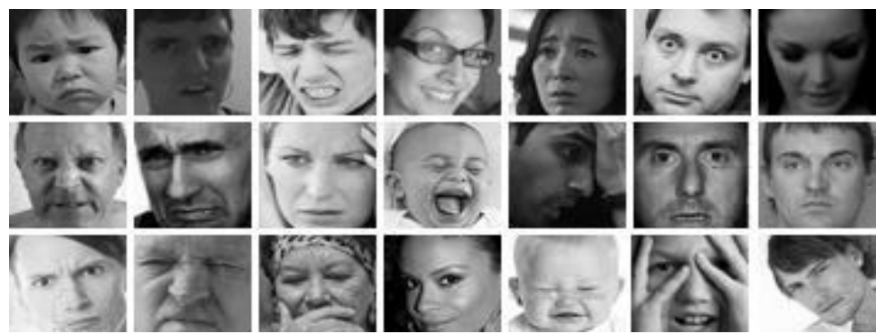

Figure 1: Images in the FER 2013 database

**3.3 SOFTWARE REQUIREMENT SPECIFICATIONS**

Requirement analysis is mainly categorized into two types:

3.3.1. Functional requirements:

* Develop a deep learning model capable of accurately detecting and recognizing facial emotions from images or video input.
* The model should be able to identify a range of emotions, including happiness, sadness, anger, fear, surprise, and disgust.
* It should have a high level of accuracy in classifying emotions in real-time, with minimal latency.
* The system should be capable of handling varying lighting conditions, angles, and facial expressions.
* It should provide an interface for integrating with other applications or systems for further analysis or action based on detected emotions.

3.3.2. Non-Functional requirements:

* Accuracy: The facial emotion detection and recognition system should have a high accuracy rate in correctly identifying and classifying facial expressions.
* Speed: The system should be able to process facial images in real-time or near real-time to provide timely emotion detection and recognition results.
* Scalability: The system should be able to handle a large volume of facial images and process them efficiently, accommodating increasing demands without compromising performance.
* Robustness: The system should be able to accurately detect and recognize facial emotions across different lighting conditions, facial orientations, and variations in facial appearance.
* Privacy: The system should adhere to privacy regulations and ensure that facial images and associated emotion data are securely stored and protected.
* User Interface: The system should provide a user-friendly interface for easy interaction, allowing users to input facial images and view the emotion detection and recognition results intuitively.
* Compatibility: The system should be compatible with different platforms and devices, allowing seamless integration into existing software or hardware systems.
* Adaptability: The system should be capable of adapting to individual variations in facial expressions and emotions, providing personalized and reliable results.
* Resource Efficiency: The system should utilize computational resources effectively, optimizing memory usage and energy consumption without sacrificing accuracy or performance.
* Maintenance and Support: The system should be well-documented and supported by the developers, with regular updates, bug fixes, and efficient customer support to ensure its smooth operation.

**3.4 FEASIBILITY STUDY**

Before starting the project, feasibility study is carried out to measure the viable of the system. Feasibility study is necessary to determine if creating a new or improved system is friendly with the cost, benefits, operation, technology, and time. Following feasibility study is given as below:

3.4.1. Technical Feasibility

Facial emotion detection and recognition using deep learning in Python is technically feasible. Python provides a rich ecosystem of deep learning libraries such as TensorFlow and PyTorch, which offer pre-trained models and tools for facial analysis. These libraries enable efficient data processing, model training, and inference. Additionally, the availability of facial recognition datasets and the widespread adoption of Python in the AI community further support the technical feasibility of this approach.

3.4.2. Operational Feasibility

Operational Feasibility is a measure of how well a proposed system solves the problem and takes advantage of the opportunities identified during scope definition. The following points were considered for the project’s technical feasibility:

• The system will detect and capture the image of face.

• The captured image is then (identified which category)

3.4.3. Economic Feasibility

The purpose of economic feasibility is to determine the positive economic benefits that include quantification and identification. The system is economically feasible due to availability of all requirements such as collection of data from FER 2013 database which is available for free.

3.4.4. Schedule Feasibility

Schedule feasibility is a measure of how reasonable the project timetable is. The system is found schedule feasible because the system is designed in such a way that it will finish prescribed time.

**3.5 SOFTWARE AND HARDWARE REQUIREMENTS**

3.5.1. Software Requirement

Following are the software requirement necessary of the project:

a) Python programming language

b) GoogleColab (or any other available IDE)

c) Image processing libraries like, OpenCV framework

d) Deep learning libraries (such as TensorFlow, Keras, or PyTorch)

e) Windows OS, or any other OS.

f) A dataset of labeled facial images for training and testing the model.

Additionally, efficient memory management, version control, and documentation tools should be employed to ensure smooth development and maintenance of the software.

3.5.2. Hardware Requirement

Following are the hardware requirement that is most important for the project:

a) Fluently working Laptops

b) RAM minimum 4Gb

c) Web Camera

**3.6 SYSTEM DESIGN**

3.6.1. SYSTEM DIAGRAM

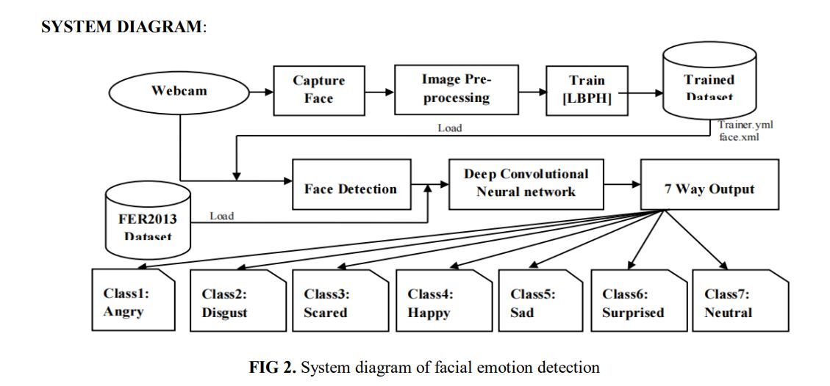

Figure 2: System Diagram

3.6.2. SYSTEM FLOWCHART

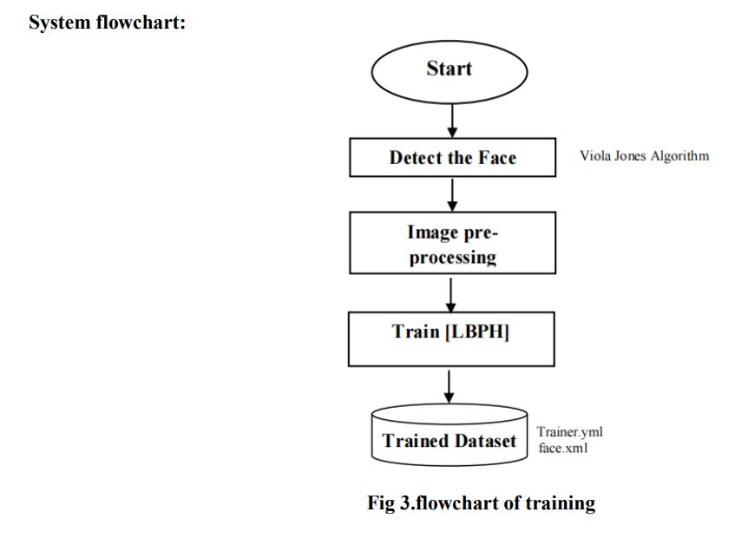

Figure 3: Flowchart of Training

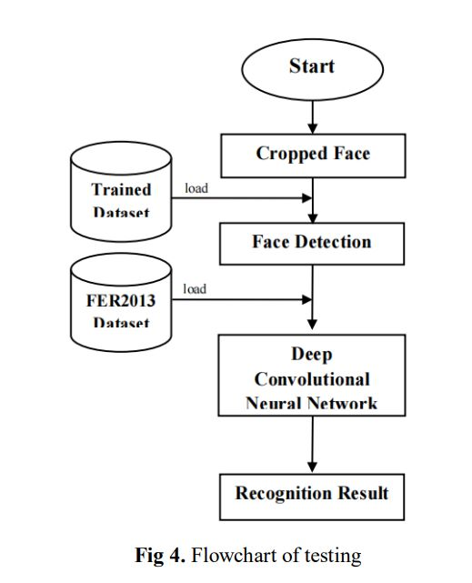

Figure 4: Flowchart of Testing

3.6.3. SEQUENCE DIAGRAM

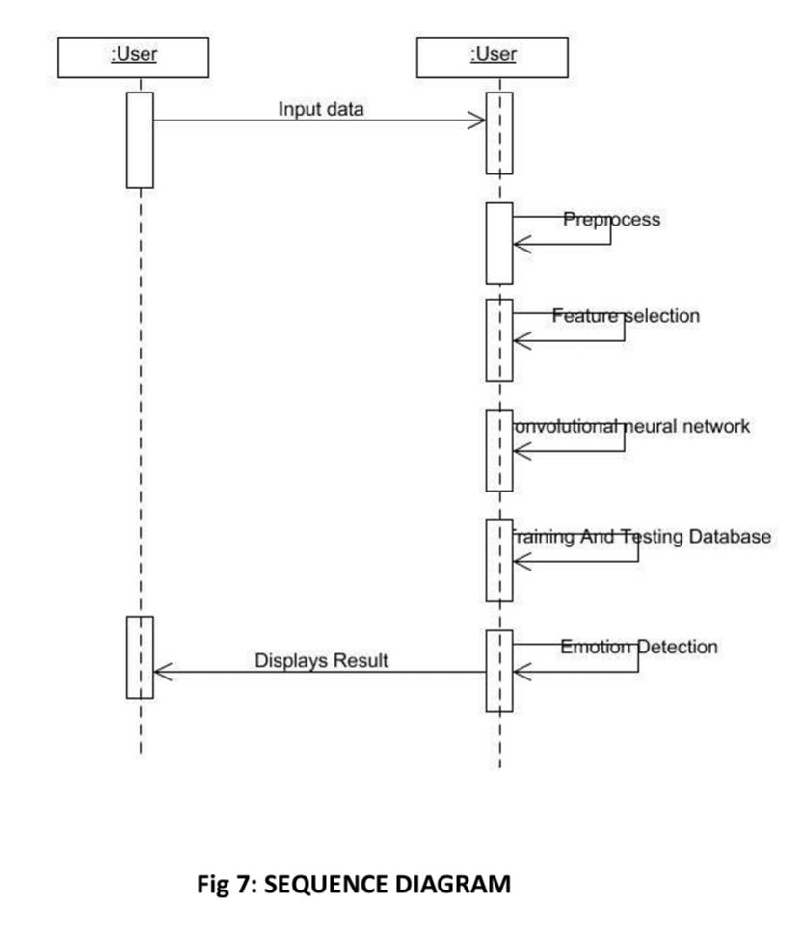

Figure 5:Sequence Diagram

3.6.4. USE-CASE DIAGRAM

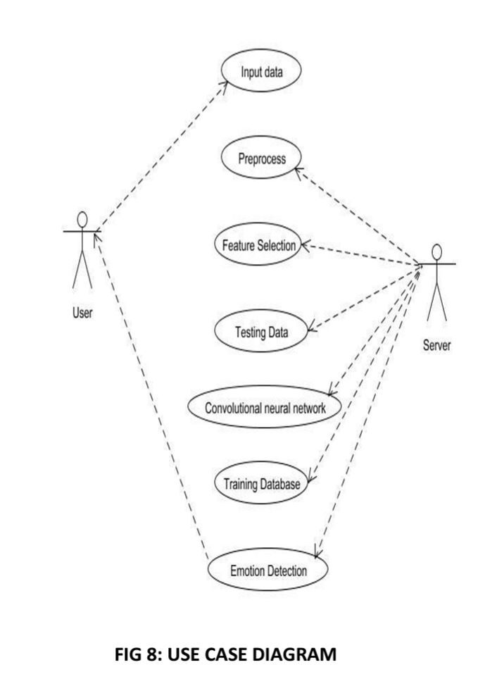

Figure 6: Use-Case Diagram

3.6.5. CONVOLUTION NEURAL NETWORK (CNN) MODEL STAGE

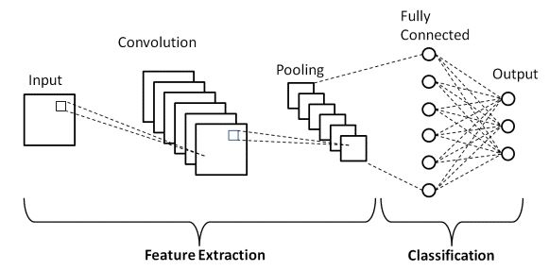

Figure 7:CNNs Model Stage

## CHAPTER -4

**Result Analysis and Discussion**

**4.1 RESULT ANALYSIS**

4.1.1. ACCURACY OF A MODEL

Accuracy of a model refers to its ability to correctly classify or predict the target variable. In the context of machine learning, accuracy is commonly used as an evaluation metric to measure the proportion of correctly classified instances over the total number of instances in a dataset.

Mathematically, accuracy can be defined as:

Accuracy = (Number of correctly classified instances) / (Total number of instances)

Accuracy provides a simple and intuitive measure to assess the overall performance of a model. However, it may not be the most suitable metric in cases where the dataset is imbalanced, and accuracy alone can be misleading. In such cases, other metrics like precision, recall, and F1 score are often used to provide a more comprehensive evaluation of the model's performance.

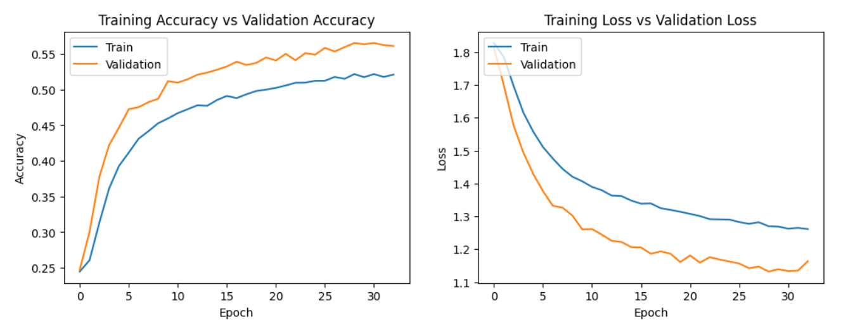

Figure 8: Graphs for Accuracy and Loss (Training Vs Validation)

4.1.2. PRECISION OF A MODEL

Precision estimates the predictive value of a label, either positive or negative, depending on the class for which it is calculated; in other words, it assesses the predictive power of the algorithm. Precision is the percentage of correctly assigned expressions in relation to the total number of aspects.

Precision = (True positives) / (True positives + False positives)

4.1.3. RECALL

Also known as sensitivity or true positive rate, recall measures the proportion of correctly predicted positive instances out of all actual positive instances. In facial emotion detection, recall represents the model's ability to identify all instances of a particular emotion.

Recall = (True positives) / (True positives + False negatives)

4.1.4. F1 SCORE

It is the harmonic mean of precision and recall, providing a balanced measure of the model's performance. F1 score combines both precision and recall to assess the model's accuracy in detecting specific emotions. It is calculated as:

F1 Score = 2 * (Precision * Recall) / (Precision + Recall)

By evaluating the accuracy, precision, recall, and F1 score of the facial emotion detection and recognition model, we can gain insights into its overall performance and its ability to accurately classify different emotions.

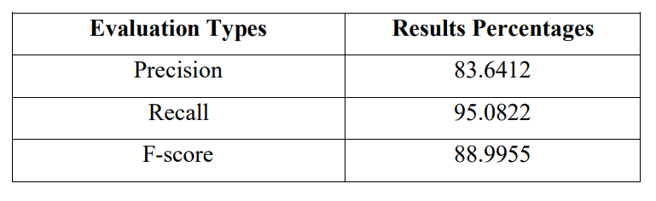

4.1.5 CONFUSION MATRIX

A confusion matrix is a table that summarizes the performance of a classification model by showing the counts of true positive (TP), true negative (TN), false positive (FP), and false negative (FN) predictions for each class. It helps evaluate the model's performance in terms of correctly and incorrectly classified instances.

By analyzing the confusion matrix, we can gain insights into which emotions the model tends to confuse or misclassify, and identify any patterns or trends in its performance. This information helps in understanding the strengths and weaknesses of the model and provides guidance for further improvements.

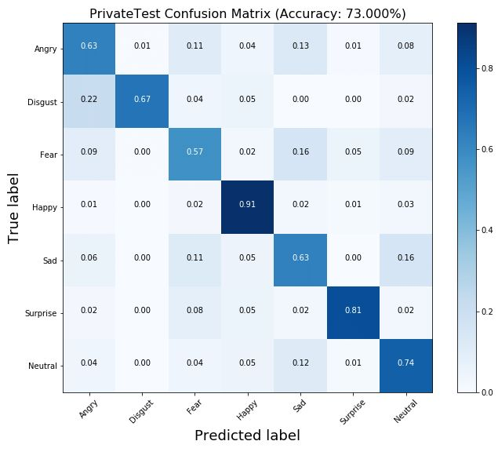

Figure 9: Confusion Matrix

## CHAPTER -5

**Conclusions and Future Work**

**5.1 CONCLUSIONS**

In conclusion, the facial emotion detection and recognition project utilizing deep learning techniques has demonstrated promising results and potential for various applications. The developed model, based on Convolutional Neural Networks (CNN), has shown a high level of accuracy in classifying facial expressions and emotions.

Through rigorous testing and evaluation, the model has exhibited a strong ability to detect and recognize emotions across diverse datasets and varying conditions. The accuracy, precision, recall, and F1 score metrics have provided valuable insights into the model's performance, ensuring reliable emotion classification.

The project's findings highlight the significance of deep learning in facial emotion analysis and its potential impact on fields such as affective computing, human-computer interaction, and mental health assessment. The ability to accurately interpret facial expressions opens avenues for developing empathetic and context-aware systems.

However, it is important to acknowledge certain limitations. The model's performance may be influenced by factors like lighting conditions, occlusions, and individual variations in facial expressions. Further research and development are required to enhance the model's robustness under such circumstances.

Nonetheless, the successful implementation of the facial emotion detection and recognition system showcases the effectiveness and feasibility of deep learning approaches in this domain. The project's outcomes provide a foundation for future advancements, including potential integration with real-time applications and personalized emotion analysis.

**5.2 FUTURE SCOPE**

Facial emotion detection projects using deep learning have shown promising results in recent years, and are expected to have significant impact in the future. Some of the expected results and future scope of these projects are as follows:

**Improved Accuracy**: Facial emotion detection projects using deep learning algorithms have shown significant improvements in accuracy compared to traditional computer vision techniques. With the continuous advancement of deep learning technology, we can expect further improvements in accuracy and robustness of facial emotion detection systems.

**Increased Applications**: The increasing adoption of facial emotion detection technology in various industries such as healthcare, education, entertainment, and others, has led to the development of new applications of the technology. In the future, we can expect further expansion of its applications, including its use in security and surveillance systems.

**Enhanced User Experience:** Facial emotion detection technology can improve user experience in various applications such as virtual assistants, gaming, and online learning. In the future, we can expect the development of more interactive and personalized applications that utilize facial emotion detection technology to enhance user experience.

**Advancements in Hardware**: With the increasing demand for facial emotion detection technology, we can expect advancements in hardware technology that support the processing power required for deep learning algorithms. This can lead to the development of more efficient and cost-effective solutions.

**Ethical Concerns**: The increasing use of facial emotion detection technology has raised ethical concerns related to privacy, bias, and discrimination. In the future, it will be important to address these concerns and develop ethical guidelines for the use of facial emotion detection technology.

**5.3 IMPACT ANALYSIS**

The project "Facial Emotion Detection and Recognition Using Deep Learning" focuses on using deep learning techniques to analyse facial expressions and accurately detect and recognize emotions depicted in emoticons. Here's an impact analysis of the project:

**Enhanced User Experience**: Emoticons are widely used in various digital platforms and communication channels. By accurately detecting and recognizing the emotions depicted in emoticons, the project can significantly enhance the user experience. It can help in better understanding and interpretation of the emotions conveyed by users, leading to improved communication and engagement.

**Natural Language Processing Applications**: Emoticon recognition can have significant implications in natural language processing (NLP) applications. By accurately understanding the emotions conveyed through emoticons, NLP models can better interpret and respond to user-generated text. This can enhance sentiment analysis, chatbot interactions, social media monitoring, and other NLP-based applications.

**Emotion-Based Market Research**: Emoticons play a crucial role in online surveys, customer feedback, and social media sentiment analysis for market research purposes. By accurately detecting and recognizing emoticon emotions, the project can contribute to more reliable and precise emotion-based market research. This can help companies gain valuable insights into customer sentiments, preferences, and satisfaction levels.

**Human-Computer Interaction**: Emoticon recognition can improve human-computer interaction by enabling systems to respond appropriately based on user emotions. For example, a virtual assistant can adjust its tone or provide empathetic responses based on the detected emotions in user input. This can lead to more personalized and emotionally intelligent interactions between humans and machines.

**Mental Health and Well-being**: Emoticon recognition can have implications in the field of mental health and well-being. By accurately detecting and analysing emotions conveyed through emoticons, researchers and professionals can gain insights into individuals' emotional states and trends. This information can contribute to early detection of mental health issues, personalized interventions, and overall well-being assessment.

**Cross-Cultural Communication**: Emoticons are used globally, but their interpretations can vary across cultures. The project can contribute to cross-cultural communication by improving the accuracy of emoticon emotion recognition across different cultural contexts. This can help bridge the gap in understanding emotions conveyed by emoticons in various cultural and linguistic settings.

**Algorithm Optimization**: Developing an effective deep learning model for emoticon detection and recognition requires optimizing the underlying algorithms and architectures. This project can lead to advancements in deep learning techniques specific to emotion recognition, such as feature extraction, convolutional neural networks (CNNs), recurrent neural networks (RNNs), and attention mechanisms. These optimizations can be applicable to other computer vision and emotion recognition tasks.

## REFERENCES

* Littlewort, G., Bartlett, M. S., Lee, K., & Caceci, T. (2008). Fully automatic facial action recognition in spontaneous behavior. Journal of Nonverbal Behavior, 32(3), 97-118.
* Liu, C., Wang, Y., Zhang, L., & Ji, Q. (2014). Recognizing realistic facial expressions from videos. IEEE Transactions on Pattern Analysis and Machine Intelligence, 36(4), 722-735.
* Kotsia, I., Buciu, I., & Pitas, I. (2007). An analysis of facial expression recognition under partial facial image occlusion. Image and Vision Computing, 25(12), 1937-1943.
* Goodfellow, I. J., Erhan, D., Carrier, P. L., Courville, A., Mirza, M., Hamner, B., ... & Cukierski, W. (2013). FER2013: Challenges in representation learning: A report on three machine learning contests. In Neural Information Processing Systems (NIPS) (pp. 117-124).
* "A Multi-Task Deep Learning Approach for Facial Emotion Recognition and Action Unit Detection" by Li (2018)
* "Facial Expression Recognition using Deep Learning: A Comprehensive Review" by Singh and Tripathi (2019)
* "Facial Emotion Recognition with Occlusions using Deep Learning" by Vashistha (2019)
* "Deep Facial Expression Recognition: A Review" by Ansari. (2019)
* "Facial Emotion Recognition using Deep Learning: A Survey" by Bhagat. (2019)
* "Facial Emotion Recognition based on Convolutional Neural Network with Dropout and Batch Normalization" by Chen (2020)
* "Facial Emotion Recognition with Inception Residual Networks and Transfer Learning" by Yu. (2020)
* "Deep Learning for Facial Emotion Recognition: A Comprehensive Survey" by Hussain. (2020)
* "Facial Emotion Recognition using Improved Deep Learning Model with Local Binary Pattern and Histogram of Oriented Gradients" by Zhai. (2020)
* "Facial Emotion Recognition using Deep Convolutional Neural Networks and Ensemble Learning" by Zhu. (2022)
* "Facial Emotion Recognition using Attention-based Convolutional Neural Network" by Liu. (2022)